DASH GCP Cloud Run Access Guide

Input Guide
This section outlines the input parameters required for provisioning GCP Cloud Run using the DASH Portal. Each parameter includes a description, available options, usage guidance, and notes on valid combinations when applicable.

Input Parameter | Description | Values Provided | Value Guidance | Valid Combinations
container_name | Name of the container | Any alphanumeric string. | Use clear naming conventions for effective container management. | N/A
region | GCP region where the container will be deployed | us-central1, us-west1, us-south1, us-east1, asia-south1, europe-west1, europe-north1, me-central1, australia-southeast1, northamerica-northeast1 | Choose the region that is geographically closest to your end users or integrated services to minimize latency and improve performance. | N/A
instances | Maximum number of instances required to scale the Cloud Run service | 1, 2, 3, 4 | Specify the maximum number of instances to handle traffic while controlling costs and resource usage. | N/A
memory | Memory allocation for the container (Mi/Gi). | 256Mi, 512Mi, 1Gi, 2Gi, 3Gi, 4Gi | Choose the amount of memory to allocate to the container(Mi/Gi) to ensure reliable performance. | N/A
cpu | CPU allocation for the container | 1, 2, 3, 4 | Choose the amount of CPU to allocate to the container based on workload requirements. | N/A
port | Port that the containerized application will listen on. | Port number of the container | Define the port number the application listens on. | N/A
image | Public image to be deployed in Cloud Run. This image should be stored in a Docker registry (e.g., Google Container Registry or Docker Hub) | Container image | Use repoName/imageName:tag for Docker Hub images, a full URI for other registries, and provide credentials for private registries. | N/A
owner | The team or individual responsible for provisioning, managing, and maintaining the resource. | Specify the team name or individual responsible for maintaining the Cloud Run service. | Provide correct team/individual name. | N/A
application | Name of the application running inside the container. | Enter the application name running as a container. | Provide the application name. | N/A
project | Project to which Cloud Run service is associated. | Indicate the project or initiative name. | Provide the project name. | N/A
deployment | The target environment (e.g., development, testing, prod) where the Cloud Run will be provisioned. | Define the deployment environment name (e.g., dev, test, prod) | Choose the environment where the Cloud Run service has to be deployed. | N/A
Services expire after 30 days. Create this service now, or schedule for a later date? | Cloud Run service will be deleted 30 days after creation, or it can be scheduled to be created at a later date. | Create Now (or)  Schedule for Later | Choose based on Cloud Run service requirements. | N/A

Sample Input Selection:
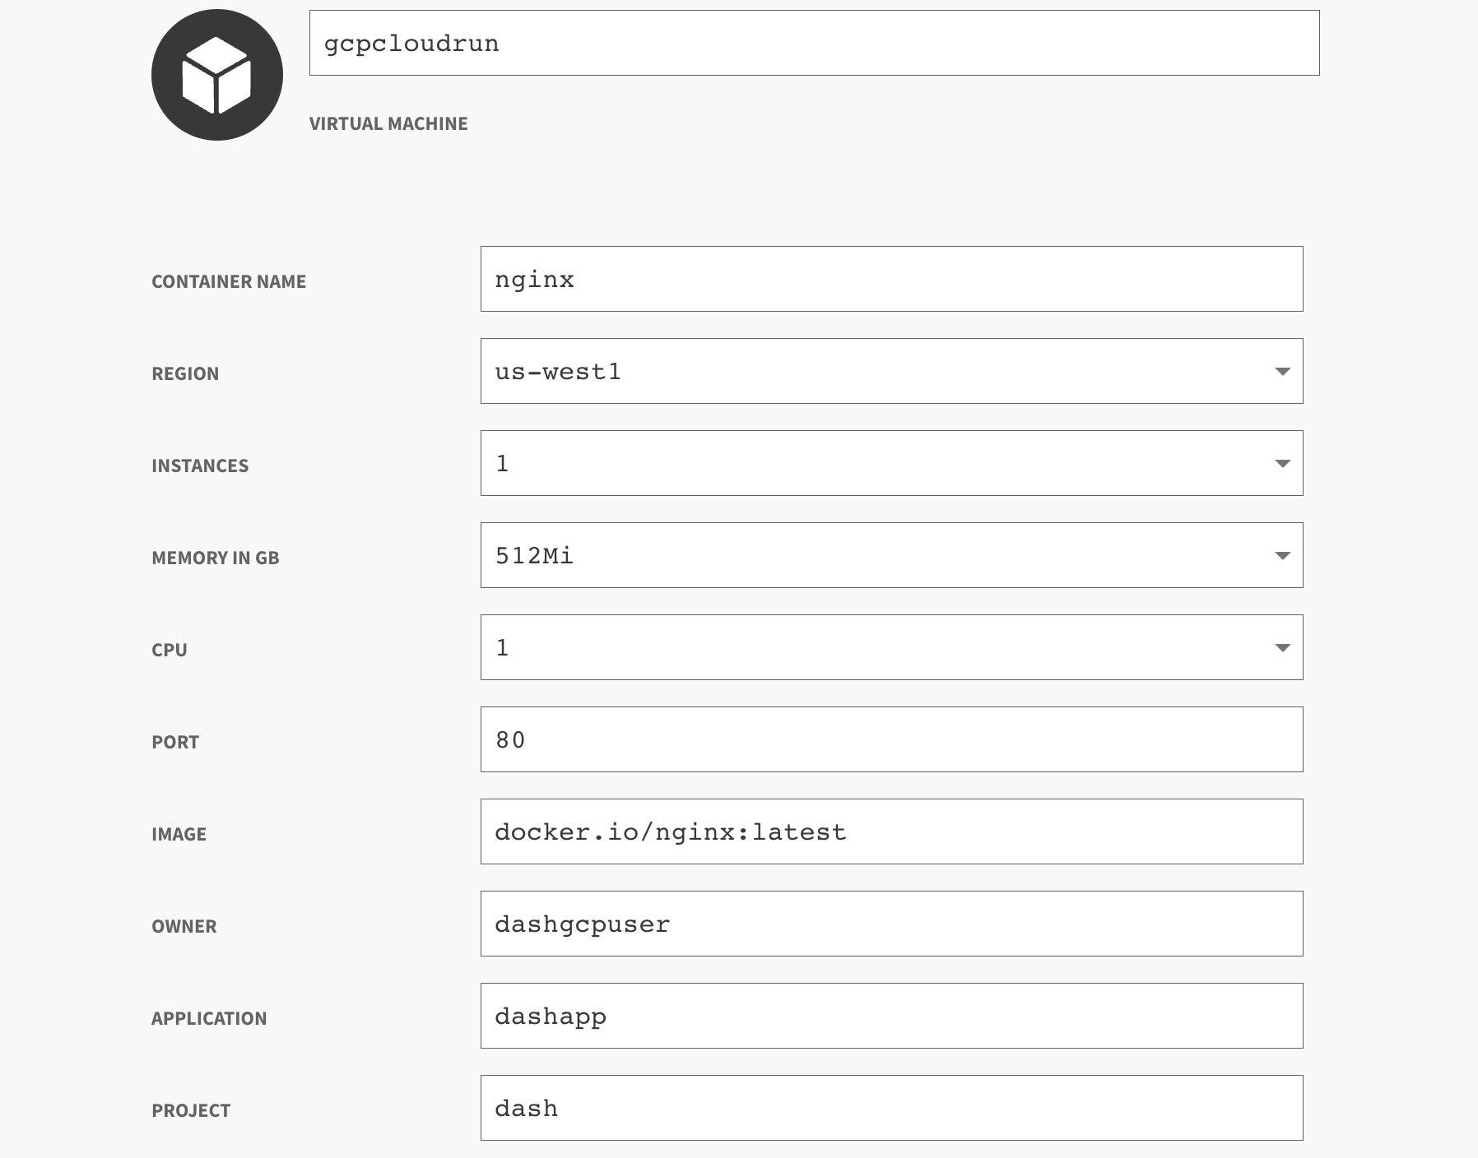
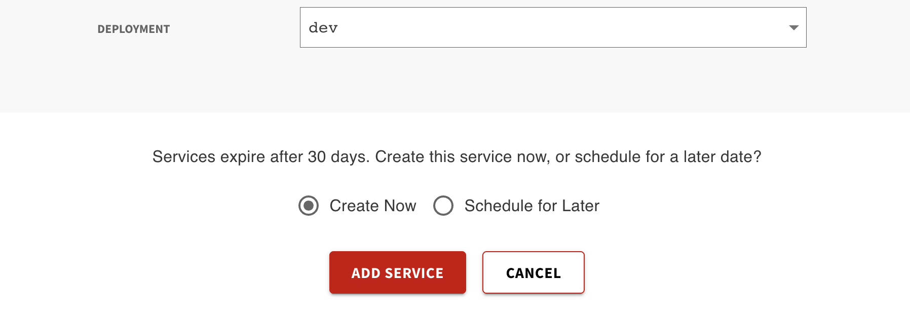

Output Guide
This section outlines the output values generated after GCP Cloud Run provisioning through the DASH Portal. These outputs can be used to access the containerized application.

Output | Description | Example Value
cloud_run_service_url | Https URL to access the application from the browser. | https://dash-nginx-9z1s-yquf2ejseq-uw.a.run.app

